

**INTERNSHIP REPORT APPROVAL FORM**

July 1, 2019

With immense pleasure, this is to approve that the students of Sona college of technology

**Preethika S**

**Santhini B**

**Saranya E**

successfully completed their Project and Project Report on **“**NUTRITION ANALYSIS USING IMAGE CLASSIFICATION**”** under our guidance.

We are highly impressed with the work that they have done and commend them on their quick grasping skills. They have shown good intent to learn and have put the knowledge gained into application in the from of this project. We appreciate the hard work and commitment shown by them.

We, hereby approve that this document is completely checked and accepted by SmartBridge Technical Team. Its been an absolute pleasure to educate and mentor these students. We hope that this document will also serve as a Letter of Recommendation, to whomsover applied.

We wish them success in all future endeavors and a great career ahead.

**GD Abhishek**

AI Developer

NUTRITION ANALYSIS USING IMAGE CLASSIFICATION

Team Name :MIND BENDERS

1. Preethika.S

2. Santhini.B

3. Saranya.E

1. **NUTRITION ANALYSIS USING IMAGE CLASSIFICATION**
   1. **INTRODUCTION**

**Python** :Python is anobject-oriented, high-level programming language and simple, easy to learn syntax readability and hence it reduces the cost of program maintenance. Pythonalso  supports modules and packagesand also we can use Python for developing desktopGUIapplications, websites and web applications.

**Artificial Intelligence (AI)** :Any technique in this world which mimic the human behavior which has the ability to do intelligence is called Artificial Intelligence. AI system requires

* Relevant data for training purpose
* Computational power to process the data

AI is an area of computer science that emphasizes the creation of intelligent machines that work and react like humans. Some of the activities computers with artificial intelligence are designed for include. There are several types of Artificial intelligence: ANI-Artificial NarrowIntelligence ,AGI- Artificial General Intelligence also known as human-level AIand ASI- Artificial Super Intelligence.

**Machine Learning(ML)** is a subset of AI techniques. It is the statistical methods to make machine intelligence and machine improvement.The various Learning types in Machine learning are as follows:

* SupervisedMachine Learning
* Unsupervised Machine Learning
* Reinforcement learning.

Deep Learning is a subset of Machine Learning(ML) which make the computation of multi layer neural network feasible.

**1.2 Objectives of Research**

The objective of this research project is to find nutritions of the detected fruit and the name of the fruit using image classification.The purpose of the project is to classify an object with higher degree of accuracy by fine tuning the parameters of the network..The main motto is to reduce the training time and compute complexity of the network by adding a sub layer after each convolution layer.

**1.3 Problem Statement**

The problem statement of this project is to find is to predict the kind of the fruit and and its nutritions.

For example: Predicted fruit : apple

Nutrients :

calories-52

Water**-**86%

Protein**-**0.3 grams

Carbs**-**13.8 grams

Sugar**-** 10.4 grams

Fiber**-**2.4 grams

The first step of approaching the demanding issue of image classification is by looking at the available data and preprocessing the huge amount of data. By preprocessing and training the huge amount of data we are able to find the prediction of the particular image and the nutrients of that particular fruit.Hence the user can get to know the nutrients of the each and every fruit and maintain the healthy body in order to lead a healthy life.

**2.Review of literature**

In this project ,CNN algorithm helps to extract the important features from the images and train according to them.

These neural networks have proven to be successful in many different real-life case studies and applications like

* Image classification, object detection, segmentation, face recognition.
* Self driving cars that leverage CNN based vision systems.
* Classification of crystal structure using a convolutional neural network.

This model involves 4 steps:

* Convolution
* Max pooling
* Flattening
* Full connection

And finally import the image using these packages to find the predictions:

**from keras.models import load_model**

**from keras.preprocessing import image**

The extension for saving the model is .h5 file

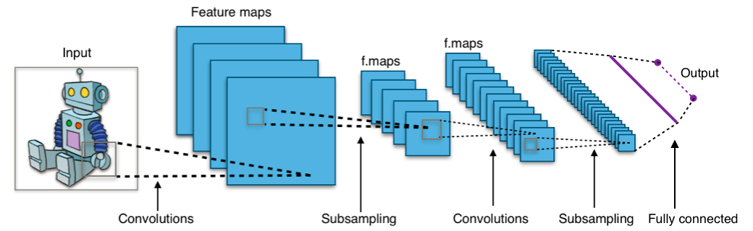

**3.Data Collection**

1.Download the dataset

2.Load the dataset

In this project ,we have used 4 datasets namely

* Apple
* Banana
* Kiwi
* Strawberry

In training dataset ,we have totally 600 images

and in testing dataset we have 200 images.

**4.Methodology**

* 1. **Exploratory Data Analysis**

**Figure 4.1.1**

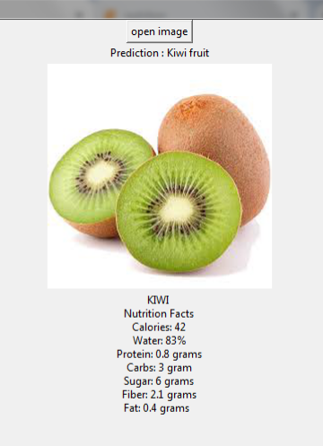

**4.2 Data Modelling**

**Convolution Neural Network (CNN)** algorithm is applied to this model .This helps us to extract the important features from the images and train them.

It has four steps namely

1. Convolution
2. Max pooling
3. Flattening
4. Full connection

In **convolution operation**,the input image is convoid with feature detector or filter to get a feature map.By applying convolution operation,the size of image is reduced we may lose some information but feature detector or filter will helps us to extract main features from image and remove unwanted features.

**Max pooling** is a technique which helps us to avoid overfitting of data and helps us to avoid special ingredients and distortions in data.

**Flattening** layer converts multi dimension pooled feature map to single dimension pooled feature map.Flattening layer is the input layer.

Start initializing the parameters and finally train the model with Keras fit() function.The model trains for 20 epochs.

Testing is similar to training, except that we don’t need to compute gradients and training targets. Instead, we take the predictions from network output, and combine them to get the real detection output.

Fit_generator is used to find the training and validation accuracy.

Imagedata generator is a class in **keras.preprocessing** package to apply some image processing to the images.

In this project the accuracy error is also good,so that the model is perfect.

1. **References**

1) <https://www.geeksforgeeks.org/image-classifier-using-cnn/>

2) Jupyter Notebook – [Conv_Net](https://github.com/Subhajit135/Convolutional_neural_network)

3) Wikipedia – [Convolutional Neural Networks](https://en.wikipedia.org/wiki/Convolutional_neural_network)

4) Stanford Course – [cs231n](http://cs231n.stanford.edu/)

5) <https://pdfs.semanticscholar.org/f8dd/7286ed56e8d9e5144158f0b79ac5559c048b.pdf>

6)

<https://cv-tricks.com/object-detection/faster-r-cnn-yolo-ssd/>

1. **Conclusion**

Convolutional neural networks (CNNs) have accomplished astonishing achievements across a variety of domains, including medical research, and an increasing interest has emerged in radiology.Detection is harder than classification, since we want not only class probabilities, but also localizations of different objects including potential small objects. Using sliding window together with a good classifier might be an option, however, we have shown that with a properly designed convolutional neural network, we can do single shot detection which is blazing fast and accurate. Hence using Convolution Neural Network(CNN)algorithm we have predicted the nutrition of the fruit which is very helpful for the user to maintain their healthy lifestyle.